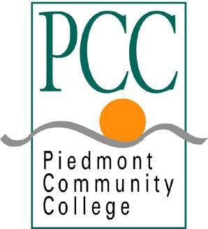

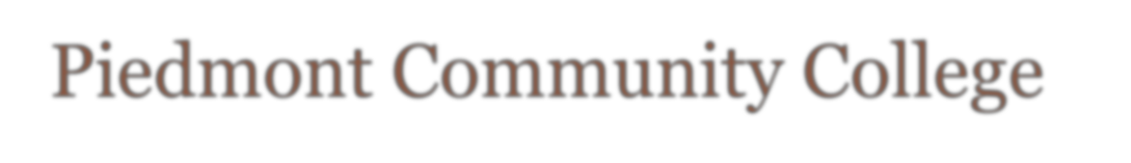

2020-21

Person County Campus Caswell County Campus
P.O. Box 1197 P.O. Box 1150
Roxboro, NC 27573 Yanceyville, NC 27379
Telephone: (336) 599-1181 Telephone: (336) 694-5707
Fax: (336) 597-3817 Fax: (336) 694-7086

Web: www.piedmontcc.edu

Approved: Oct 28, 2021
TABLE OF CONTENTS
1. Introduction ........................................................................................................................................... 3
Piedmont Community College ……………………………………………………..…………………………………………... 3
Institutional Effectiveness ………………………………………………………………………………………………………... 3
Calendar of IE-related Events (Table 1) …………………………………………………..………………………………... 4

2. Mission, Values and Vision ..................................................................................................................... 6
North Carolina Community College System Mission ...................................................................... 7

3. Goals from the Strategic Plan ................................................................................................................. 8

4. NCCCS Performance Measures for Student Success ………………………………………………………………………….. 12

5. Assessment at PCC ……………………………………………………………………………………………………………………………. 14
Program Area Outcomes (PAO) Annual Assessment ……………………………………………………………....... 14
Service Area Outcomes (SAO) Annual Assessment …………………………………………………………..………… 14
Program Area Review (PAR) Five-Year Assessment .…………………………………………………………………… 15
Service Area Review (SAR) Five-Year Assessment …………………………………………………………………….… 15

6. Other IE-Related Evaluation at PCC …………………………………………..………………………………………………………. 16

NOTE: The hardcopy archive of Piedmont Community College Institutional Effectiveness Plans is located in the Office of Research and Institutional Effectiveness, Room B-115 on the Person County Campus. Related documents and other supporting materials are available via hardcopy or in digital form by request.

- Introduction

Piedmont Community College
Piedmont Community College (PCC), a comprehensive two-year community college that began operating in 1970, is one of 58 colleges that make up the North Carolina Community College System (NCCCS). PCC serves the educational needs of the residents of Person and Caswell counties primarily through two campuses. The Person County campus in Roxboro resides on 178 acres and has 15 buildings totaling 107,000 square feet; the Caswell County campus in Yanceyville resides on 13 acres and has 2 buildings totaling 24,000 square feet. PCC also serves students through 10 additional off-campus sites. During the 2020-21 academic year, PCC served 4067 students in curriculum and continuing education programs. As of the Spring 2021 semester, PCC employed 146 full-time and 99 part-time employees.

Institutional Effectiveness (IE)
PCC employs a continuous, annual cycle of planning and evaluation to guide and gauge the achievement of the College Mission, Values, and Vision within the wider context of the mission and goals of the NCCCS as governed by the State Board of Community Colleges. Planning and evaluation activities are dictated primarily by PCC policies, are implemented primarily through the Office of Research and Institutional Effectiveness (ORIE) and are governed by the PCC Institutional Effectiveness Committee.
IE-related activities at the College generally fall into five areas:
- The IE Committee’s annual review of strategic goals of most recent Strategic Plan recommend changes to College’s Strategic Plan as needed.

- The IE Committee’s annual review of and possible recommendations for amendments to the College’s stated Mission, Values, and Vision, which should:
  - demonstrate consistency with the mission of the North Carolina Community College System and
  - be appropriate for the current needs of PCC’s service area.

- PCC’s annual results on the seven NCCCS Performance Measures for Student Success. The IE Committee formally reviews these results each year.

- Reporting of the most recent Assessment outcomes, a process which the IE Committee oversees and whose final results are reviewed by the IE Committee. There are generally two types of Assessment reports:
  - Annual assessment reports of Program Areas and Service Areas (i.e. PAO and SAO Assessment Reports)
  - Five-year assessment reviews of Program Areas and Service Areas (i.e. PAR and SAR Reviews)

- Other PCC evaluations, the completion of which the IE Committee oversees.
  - Course and instructor evaluations (currently, using CoursEval)
  - Student Satisfaction Survey (SSS)
  - Educational Support Services Survey (ESSS)
  - Graduate Survey
  - Graduation Survey
  - Other internal surveys (e.g. President/VP’s/Deans satisfaction surveys)
  - Additional measures of effectiveness such as those routinely monitored and/or generated by ORIE (e.g. retention and graduation rates) might at times also be reviewed by the IE Committee, depending on the specific year’s goals and circumstances.
The IE Plan serves as a guide to help ensure all IE-related tasks of the College are accomplished each year. As the IE Committee provides oversight, it serves in three somewhat different capacities:
- Auditor/Reviewer: primary responsibility is to ensure task completion; secondary responsibility is to review the actual level of performance (effectiveness) on each task.
- Reviewer/Evaluator: primary responsibility is to review annually the College’s mission, goals, and performance levels on the NCCCS Performance Measures for Student Success; secondary responsibility is to propose and manage the implementation of any appropriate amendments to mission and goals.
- Author: responsible for updating this IE Plan document annually.
The calendar provided below at Table 1 summarizes the IE-related activities for the 2020-21 academic year. The approximate completion date for each activity is provided. Also, because the actual timestamp date of data related to IE activities is very important, that information is included. The timestamp dates vary considerably in terms of both recentness and span. In the final “IE Committee’s Responsibility” column, the aforementioned three capacities in which the IE Committee is to generally operate are provided.
Note that the official sequence of semesters of an academic year is Summer, Fall, Spring; however, the calendar below follows the more typical sequence of semesters used by PCC’s standing committees, which is Fall, Spring, Summer. Data for an academic year is aggregated using the Summer, Fall, Spring sequence and so does not precisely match up to the academic year of a typical PCC committee calendar. Those who review and evaluate academic-year data, such as PCC IE Committee members, should take note that that academic-year data contains data for the Summer semester preceding the Fall.

Table 1. Calendar of IE-Related Tasks for 2020-21.
# | IE Task | Task Completion Date | Timestamp of Effectiveness Data Gathered/Reviewed | IE Committee’s Responsibility
1 | PAO and SAO Annual Assessment Reports Due | June 30,2021 | AY 2020-21 | Auditor/Reviewer
2 | Graduate Survey | Fall 2020 fielding; reported ~Jan 2021 | The collective time period students attended PCC (prior to 2020-21) | Auditor/Reviewer
3 | PAO and SAO Annual Assessment Reports Presented to EC | Fall 2021 | AY 2020-21 | Auditor/Reviewer
4 | 2020 – 21 IE Plan finalized | October 2021 | N/A | Author
5 | IE Committee review of PCC’s outcomes on the past Spring’s NCCCS Performance Measures | Oct 2020 | Cohorts defined at varying points (2016-17 thru 2019-20) as of 2019-20 | Reviewer/Evaluator
6 | IE Committee review of PCC’s goals | Oct 2020 | Current | Reviewer/Evaluator
7 | IE Committee review of PCC’s Mission, Values, and Vision | Oct 2020 | Current | Reviewer/Evaluator
8 | Course and Instructor Evaluations (Fall) | Nov/Dec 2020 | Fall 2020 semester | Auditor/Reviewer
9 | Educational Support Services Survey (ESSS) | Jan 2021 fielding; reported by Feb 2021 | Unspecified (presumably, the most recent year) | Auditor/Reviewer
10 | Student Satisfaction Survey (SSS) | Mar 2021 fielding; reported by Apr 2021 | Unspecified (the collective time period students attended PCC (up to Mar 2021) and presumably heavily the most recent year) | Auditor/Reviewer
11 | President/VP’s/Deans evaluation surveys | Mar 2021 fielding; reported by Mar 2021 (Deans: April 2021) | Unspecified (presumably, currently and/or the most recent year) | Auditor/Reviewer
12 | Course and Instructor Evaluations (Spring) | April/May2021 | Spring 2021 semester | Auditor/Reviewer
13 | PAR and SAR Five-Year Reviews Due | May 2021 | 5 AY’s 2016-17 thru 2020-21 | Auditor/Reviewer
14 | Graduation Survey | May 2021 fielding and reporting | The collective time period students attended PCC, including 2020-21 | Auditor/Reviewer
15 | Course and Instructor Evaluations (Summer) | July 2021 | Summer 2021 semester | Auditor/Reviewer

Coinciding with the three “Reviewer/Evaluator” activities of the IE Committee, distinct chapters in this IE Plan provide the College’s:
- Statements of Mission, Values, and Vision.
- Goals from the most recent Strategic Plan.
- Performance results on the most recent NCCCS Performance Measures for Student Success.

- Mission, Values, and Vision

PCC’s Mission, Values, and Vision statements were most recently updated during the development of the 2015-2020 College Strategic Plan. These revised statements and the Strategic Plan were approved by the College Board of Trustees in July 2015.
Mission
Piedmont Community College enriches lives by providing education, training, and cultural opportunities for lifelong learning and professional success in local, regional, and global communities.
Values
Learning-Centered Philosophy
The College embraces a learning-centered instructional environment supporting multiple student learning styles.
Economic Development
The College acts as a catalyst for local and regional economic development by providing education and training to address current and emerging workforce needs.
Accessibility
The College provides affordable and accessible education and training.
Diversity/Global Citizenship
The College promotes understanding and appreciation of diverse cultures and global citizenship.
Ethics/Social Responsibility
The College values the principles of personal ethics, integrity, academic honesty, civic responsibility, and accountability.
Resources
The College provides learning resources and student development support designed to address diverse student learning styles and academic needs.
Student Success
The College values individual student success as the single best indicator of institutional effectiveness in the community.

Vision
Piedmont Community College strives to be the leading contributor to the economic, educational, and cultural vitality of our communities by providing high-quality services and programs that ensure student success in personal development and professional achievement.
NCCCS Mission
The Piedmont Community College Mission and Vision resonate closely with the Mission of the North Carolina Community College System (adopted by the State Board of Community Colleges, October 1993; revised March 1994, April 1994; reaffirmed January 1998; revised and adopted June 1998; revised and adopted September 2006):
The mission of the North Carolina Community College System is to open the door to high-quality, accessible educational opportunities that minimize barriers to post-secondary education, maximize student success, develop a globally and multi-culturally competent workforce, and improve the lives and well-being of individuals by providing:
• Education, training and retraining for the workforce including basic skills and literacy education, occupational and pre-baccalaureate programs.
• Support for economic development through services to and in partnership with business and industry and in collaboration with the University of North Carolina System and private colleges and universities.
• Services to communities and individuals which improve the quality of life.

- Goals from the Strategic Plan

PCC’s goals (objectives) from the most recent PCC Strategic Plan for 2015-2020 are provided below

Strategic Theme 1: BRANDING, MARKETING, AND PROMOTION
Objective 1.1: BRANDING MESSAGES
The College will develop branding messages that communicate the mission, vision, values, and program strengths to our multiple community constituencies, including prospective students and their parents, area employers, civic leaders, and elected officials.
Here’s what we’ve accomplished…

Objective 1.2: GENERAL RECRUITMENT
The College will develop a comprehensive marketing plan and general recruitment strategies that address the diverse education and training needs/interests of various prospective student populations using current and emerging communication modes and technologies.

Objective 1.3: HIGH SCHOOL RECRUITMENT
The College will develop and implement a specific marketing plan for recruiting at high schools and with high school students and their parents to achieve the following outcomes:
- Increase the percentage of high school students who complete at least one College course while still in high school;
- Increase the percentage of high school students who earn at least one semester of full-time college credit while still in high school;
- Increase the percentage of high school students who enroll at the College within one year of high school graduation.

Strategic Theme 2: RESPONSIVE PROGRAM DEVELOPMENT
Objective 2.1: CURRICULUM PROGRAMS
The College will expedite development and implementation of new curriculum programs responsive to transfer student interests and employment demand disclosed by the Gap Analysis and other regional education and employment data.

Objective 2.2: CONTINUING EDUCATION PROGRAMS
The College will work closely with local and area employers to create and implement continuing education programs leading to industry-recognized credentials addressing: (1) current and emerging workforce needs and (2) other employment demand identified by the Gap Analysis.

Objective 2.3: PROGRAM RESOURCES
To supplement resources available for new program development, the College will closely monitor operating outcomes to reallocate from programs suffering enrollment decline reflecting limited employment and/or transfer demand.

Objective 2.4: DELIVERY OF SERVICES AND INSTRUCTION
The College will continue developing, monitoring and improving the delivery of instruction and student support services via multiple delivery modes using current and emerging technologies.

Objective 2.5: STUDENT SUCCESS LEARNING INSTITUTE (SSLI) INITIATIVE
The College will actively participate in the SSLI initiative to improve student persistence, progress, completion, and subsequent academic and/or employment success.

Strategic Theme 3: PARTNERSHIPS
Objective 3.1: PUBLIC SCHOOL ARTICULATION
The College will pursue multiple initiatives with traditional and charter public schools and with home school parents to improve student progress and completion rates in PCC programs, including:
- Establishment of a Cooperative Innovative High School for Person County high school students on the Person County Campus enrolling students beginning in fall 2016.
- Establishment of a Cooperative Innovative High School for Caswell County high school students on the Caswell County Campus enrolling students beginning in fall 2016.
- Establishment of a Cooperative Middle School for Person County students at the Timberlake Center beginning fall 2018.

Objective 3.2: TRANSFER ARTICULATION WITH FOUR-YEAR INSTITUTIONS
The College will develop or update existing articulation agreements with the four-year institutions to which the largest numbers of PCC alumni transfer, and will establish additional articulations with other UNC institutions and private four-year institutions within North Carolina and Virginia.

Objective 3.3: HIGHER EDUCATION CENTER
The College will establish a Higher Education Center collaborating with area colleges and universities to offer Bachelor’s and Master’s degree coursework in selected programs on the Person County Campus.

Objective 3.4: ECONOMIC DEVELOPMENT
The College will work with governmental economic development departments and Workforce Development Boards to create and deliver education and customized training to address explicitly commissioned workforce requirements for attracting at least one major new employer to the College service area.

Strategic Theme 4: EFFECTIVENESS
Objective 4.1: INSTITUTIONAL RESEARCH
The College will implement the Institutional Research Data Solution developed by the Center for Applied Research at
Central Piedmont Community College, to strengthen institutional research capacity for monitoring multiple measures of student retention, progress and success, as well as other indicators of operating performa nce specified in this Strategic Plan.

Objective 4.2: OPERATING EFFICIENCIES
The College will continue work to develop and refine institutional research capabilities for monitoring operating efficiencies among all service areas and educational program areas.

Objective 4.3: OUTCOMES EFFECTIVENESS
The College will continue to strengthen service area and student learning outcomes effectiveness assessment and the uses of assessment results to improve teaching and learning, shorten completion times, and reduce student educational expense.

Objective 4.4: STRATEGIC ACTION PLANS
The College Vice Presidents will direct the development of individual action plans for executing objectives of this Strategic Plan within each College Division, including task lists, target dates, lead and supporting staff and faculty accountable, projected resource requirements, and intended outcomes with performance indicators and targets. The President and Vice Presidents will establish budget priorities for items in these action plans and adjust timelines accordingly.

Strategic Theme 5: CAPITAL NEEDS AND RESOURCE DEVELOPMENT
Objective 5.1: FACILITIES MASTER PLAN
The College will seek support from Person County and Caswell County to contract with a professional consultant for development of an updated Facilities Master Plan, specifically including infrastructure and building construction or acquisition and renovation to accommodate:
- Facilities needs of current and anticipated allied health programs;
- Long-term facilities needs of the Cooperative Innovative High Schools described in Strategic Theme 3;
- Projected instructional facilities needs of Bachelor’s and/or Master’s degree courses offered on the Person County campus in the Higher Education Center described in Strategic Theme 3;
- Establishment of a second ingress/egress road to improve the convenience and safety of access to and from the Person County Campus;
- New space and facilities needs on the Caswell Campus to address anticipated workforce needs identified by the Gap Analysis.

Objective 5.2: BOND ISSUE
The College will work with appropriate government agencies to develop a bond proposal strategy to secure financing for major capital needs for facilities and equipment identified in the updated Facilities Master Plan described above.

Objective 5.3: CAPITAL FUND-RAISING CAMPAIGN
The College will plan and execute a comprehensive capital fund-raising campaign to support multiple initiatives in this Strategic Plan and the updated Facilities Master Plan, including program start -up expenses as well as facilities and equipment.

- NCCCS Performance Measures for Student Success

The NCCCS office has developed and annually computes and reports for all 58 NC community colleges seven performance measures. Descriptions of these measures are provided below (taken directly from the NCCCS website August 2021).

The NC Community Colleges System Office facilitates and supports college and system fulfillment of national, regional, and state reporting requirements. Associated reporting efforts help colleges identify institutional strengths and weaknesses by providing access to historical trends and peer comparisons.

State Performance Measures
The Performance Measures for Student Success Report is the North Carolina Community College System’s major accountability document. This annual performance report is based on data compiled during the previous year and serves to inform colleges and the public on the performance of our 58 community colleges.

2021 Performance Measures:
A. Basic Skills Student Progress
Percentage of Basic Skills students who achieve an Educational Functioning Level gain during the program year (July 1 – June 30).

B. Student Success Rate in College-Level English Courses
Percentage of first-time Associate Degree seeking and transfer pathway students passing a credit-bearing English course with a “C” or better within two years of their first term of enrollment.

C. Student Success Rate in College‐Level Math Courses
Percentage of first-time Associate Degree seeking and transfer pathway students passing a credit-bearing Math course with a “C” or better within two years of their first term of enrollment.

D. First Year Progression
Percentage of first-time fall curriculum students attempting at least 12 credit hours who successfully complete at least 12 hours within their first academic year (fall, spring, summer).

E. Curriculum Completion
Percentage of first-time fall curriculum students who, within six years of first term of enrollment, have either graduated, transferred, or are still enrolled with at least 36 non-developmental credit hours.

F. Licensure and Certification Passing Rate
Aggregate institutional passing rate of first-time test-takers on licensure and certification exams. Exams included in this measure are state mandated exams which candidates must pass before becoming active practitioners.

G. College Transfer Performance
The percentage of students who exited NCCCS after having completed an Associate Degree and/or least 30 cumulative hours of articulated transfer credits and subsequently transferred to a four-year college or university and earned a GPA of 2.25 or better after two consecutive semesters within the academic year at the institution.
PCC’s Results on the Seven NCCCS Performance Measures
PCC’s trended results on the performance measures, with the most recent data from the 2021 report, are presented below. The implied goal is to achieve performance at least above Baseline. For more detailed information on the performance measures, such as detailed cohort definitions or results for other NCCCS colleges, please contact PCC’s Director, Research and Institutional Effectiveness.
Figure 1. Trend Charts for PCC’s Performance Measures as of Spring 2021.
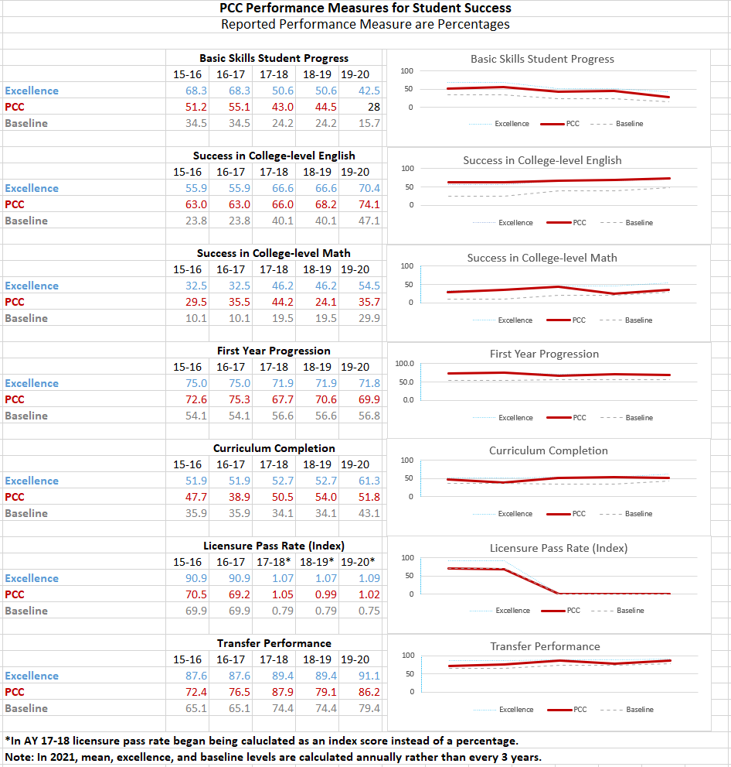

- Assessment at PCC

PCC’s thorough, well-structured assessment of teaching units (i.e. curriculum and continuing-education programs) and non-teaching units is at the heart of institutional effectiveness. Each year all teaching and non-teaching IE units prepare a thorough assessment on pre-selected measures of effectiveness to gauge how well they have performed in the past year. These measures are reported via either a Program Area Outcomes (PAO) Assessment Report (teaching units) or a Service Area Outcomes (SAO) Assessment Report (non-teaching units). In addition, once every five years each unit also conducts a more comprehensive self-review, including input from parties outside of PCC; the results are reported through either a Program Area Review (PAR) report (teaching units) or a Service Area Review (SAR) report (non-teaching units).

Annual PAO/SAO Assessment Reports
All PAO/SAO Assessment Reports follow a set format that includes:
- A table of desired broad goals (for the program for PAO’s and for the College or unit for SAO’s), desired unit outcomes, and performance levels on each outcome for the most recent academic year plus historical performances for two more years.
- A table of unit strengths, weaknesses, and action plans for the future.
- Additional useful information such as a Curriculum Map.
Annual PAO and SAO Assessment Reports and due by the end of June each year. PAO and SAO Assessment Reports are available online in the WEAVE accreditation management system. Older PAO and SAO Assessment Reports are found on the T drive at: T:\# Assessment

All PAO and SAO Assessment Reports are also presented in person to the Executive Council (EC) during the Fall semester.

Five-Year PAR/SAR Assessment Reviews
More comprehensive assessments, Program Area Review (PAR) and Service Area Review (SAR) reports, are completed once every five years by each unit. As these are rotated, each year approximately 20% of College units complete a PAR or SAR report. Current and older PAR and SAR reports are found on the T drive at:
T:\Program Area and Service Area Reviews
The Program Area Review uses general and operating data to illustrate program health. Similarly, the Service Area Review uses data to provide evidence of delivering high quality service. The PAR concentrates particularly on summative direct and indirect measures of program operating effectiveness in addition to the formative results of Program Area Outcomes (PAO) assessment whereas the SAR uses direct and indirect measures of service area operating effectiveness. PAR authors and input providers are typically full‐ and part‐time faculty who teach the program courses together with program students, graduates, and Advisory Committee members (including employers) who work with the Curriculum Area Directors or Coordinators responsible for the Program. Authors and input providers to a SAR are typically the full‐ and part‐time staff who work in the service area together with service clients (students, faculty, staff, or others).
Typical Major Content Areas of a PAR Report
- Program Profile (including faculty qualifications and student demographics)
- Program Content
- Program Area Outcomes (PAO) Assessment Plan and Results
- Strengths, Weaknesses, Opportunities and Threats (SWOT) Analysis
- Recommendations to Improve the Program
- Executive Summary

Typical Major Content Areas of a SAR Report
- Service Area Profile (including full-time and part-time staff qualifications)
- Services and Delivery
- Strengths, Weaknesses, Opportunities and Threats (SWOT) Analysis
- Recommendations to Improve Service
- Executive Summary

- Other IE-Related Evaluation at PCC

Course and Instructor Evaluations
At PCC, 100% of Curriculum courses and instructors are evaluated each semester. PCC’s Office of Research and Institutional Effectiveness (ORIE) administers the process. PCC employs the CoursEval instrument and online data collection methodology. Results are disseminated to the appropriate Deans, VP’s, and faculty.

Annual Surveys
PCC’s Office of Research and Institutional Effectiveness (ORIE) administers the following surveys on an annual basis.
- Student Satisfaction Survey (SSS)
- Educational Support Services Survey (ESSS)
- Graduate Survey
- Graduation Survey
- President/VP’s/Deans evaluation surveys
The dates of administration of each of the above surveys can be found in Table 1 in the Introduction section of this document. Results for the Student Satisfaction Survey (SSS), the Educational Support Services Survey (ESSS), and the Graduation Survey can be found on the PCC website. Results from the other surveys are disseminated to and used by appropriate College personnel.

Additional measures such as those routinely monitored and/or generated by ORIE (e.g. retention and graduation rates) might at times also be reviewed by the IE Committee and used in helping the College attain effectiveness.

This number represents the unduplicated head count of students enrolled in one or more programs at the College any time during the 2020 - 2021 academic year (Source: 2020-21 Enrollment Dashboard, North Carolina Community College System).

